1. **Configure VPC peering in cross regions.**

**Create requester VPC**

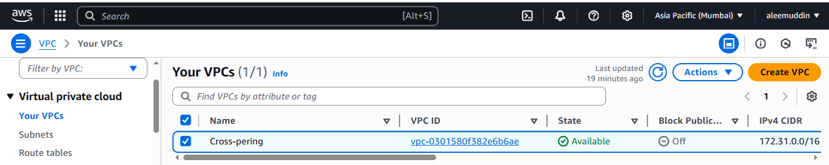

**Create acceptor VPC**

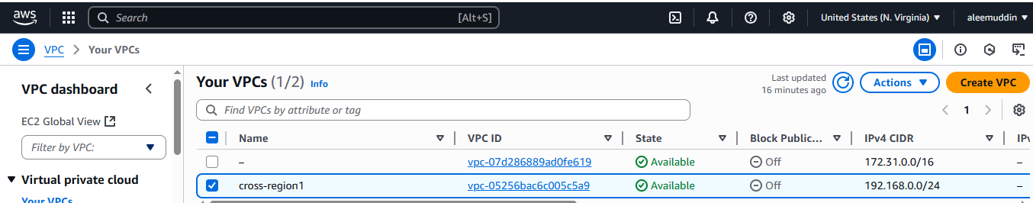

**Peering from requester VPC**

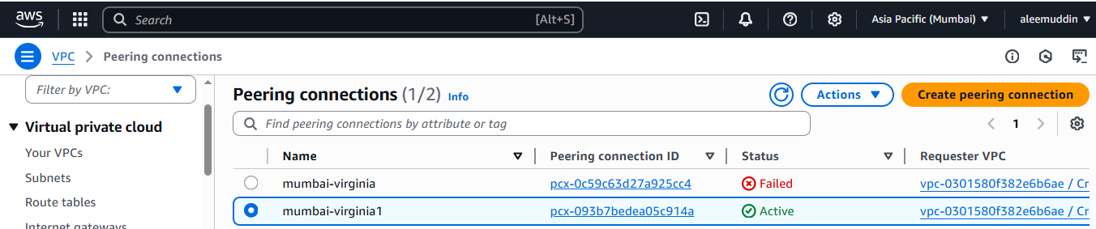

**Add requestor CRDI at acceptor**

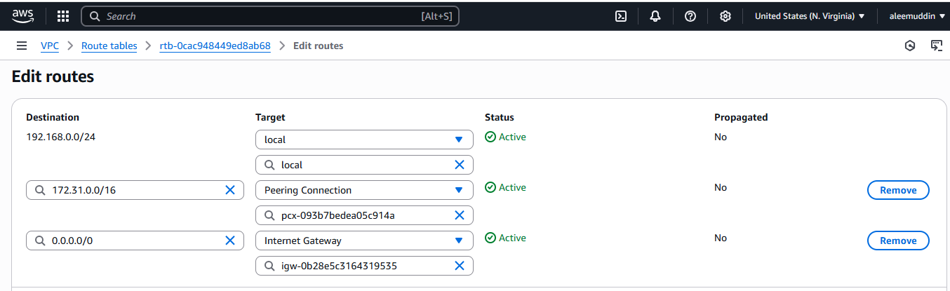

**Execute the output using public & private IP**

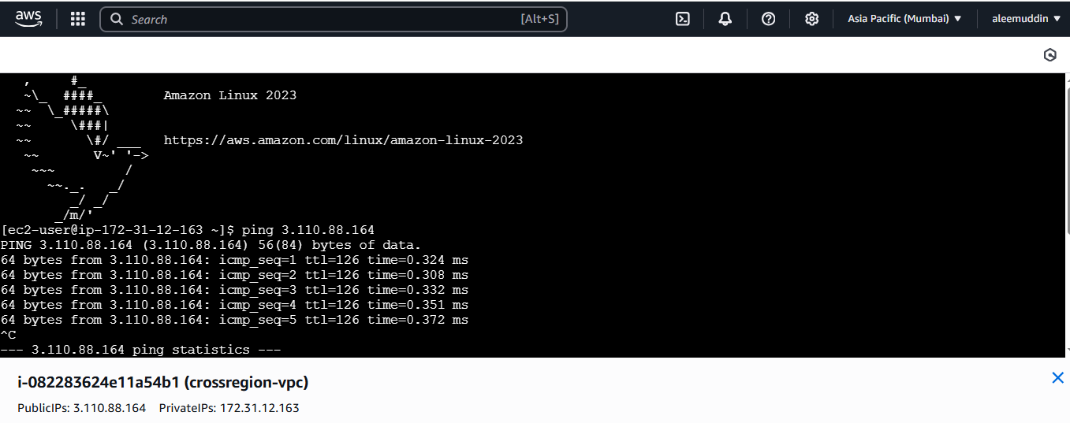

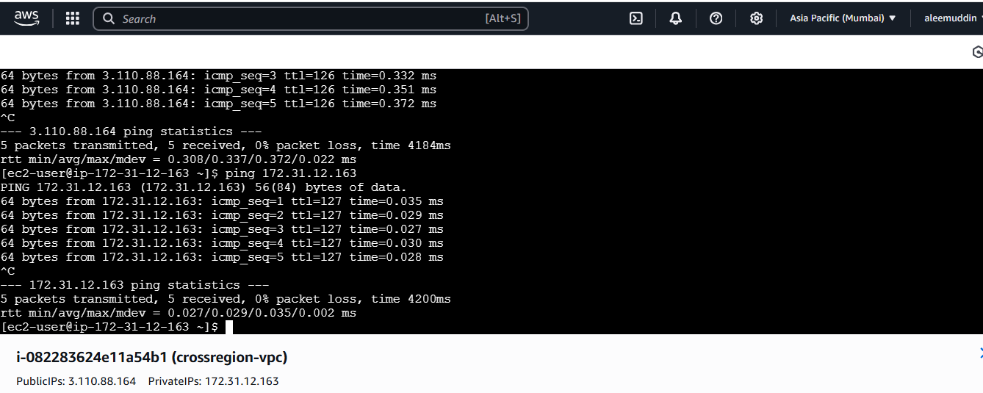

1. **Purchase one domain from godaddy.**

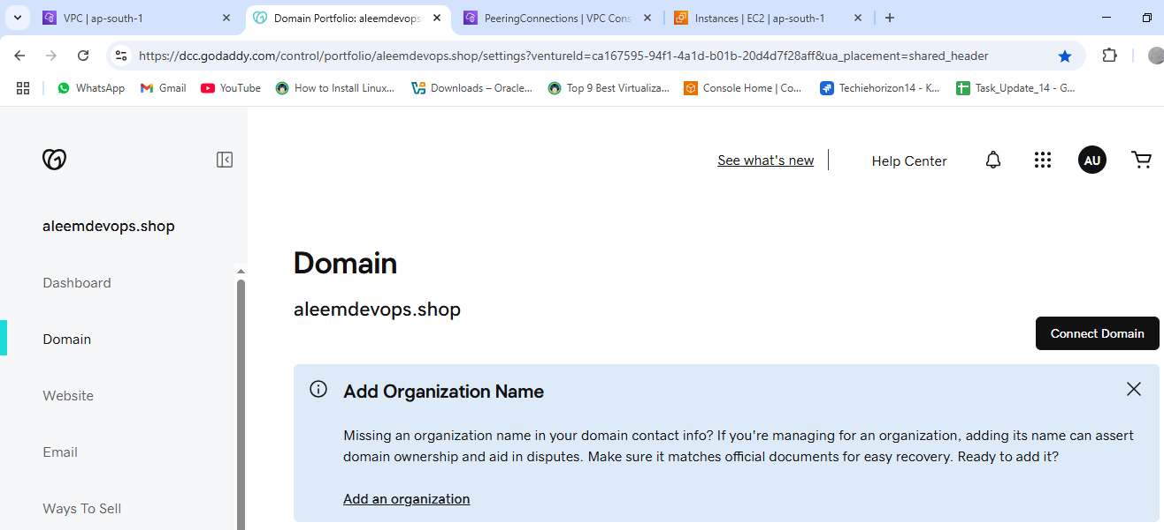

aleemdevops.shop

1. **Deploy static webiste in s3.**

**Create one bucket**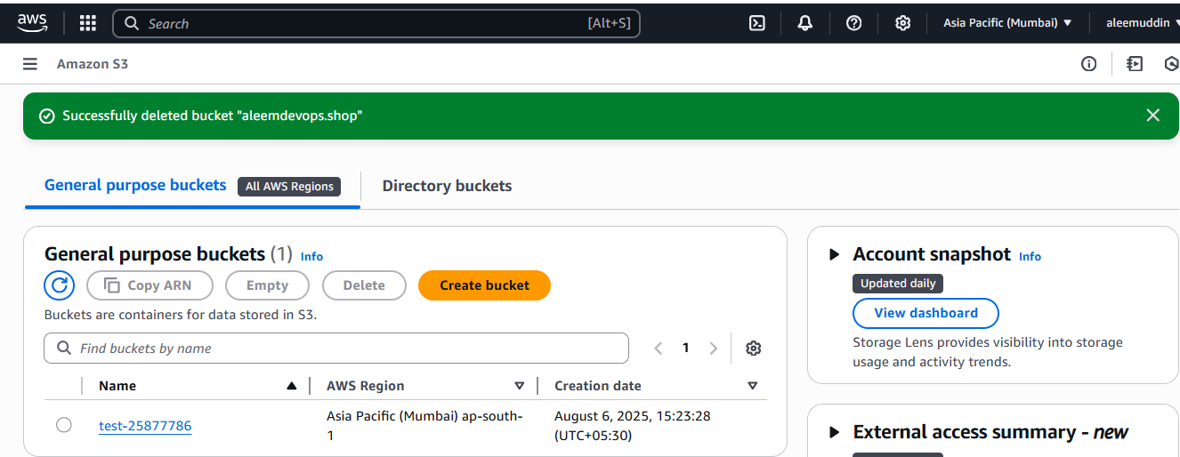

**Enable the static website hosting (Properties)**

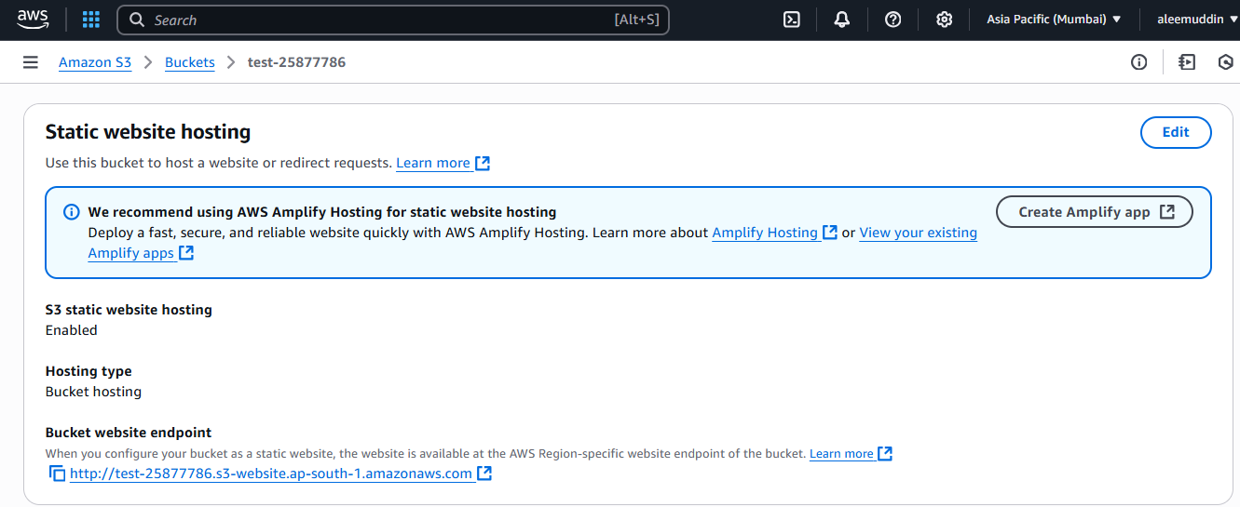

Add objects in the bucket

c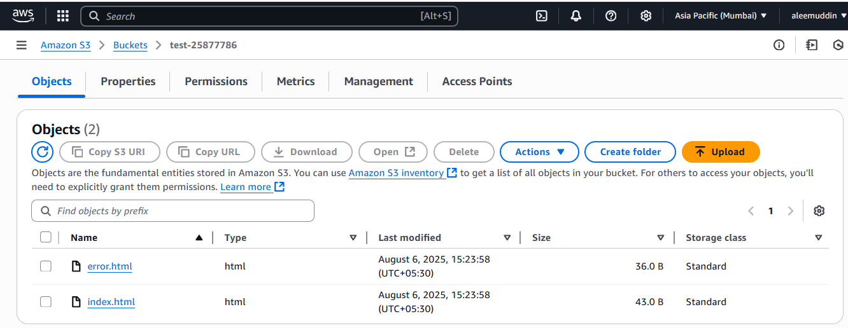

Copy the url and paste in the Browser for each file

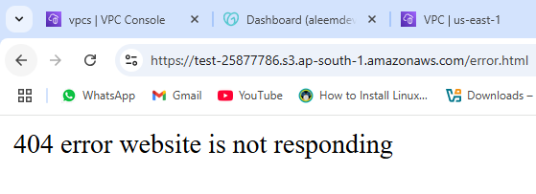

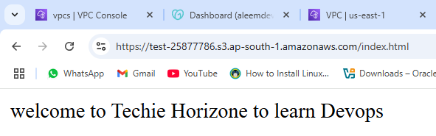

1. **Create CDN and attach one SSL certificate.**

**Amazon CloudFront is a content delivery network (CDN) service offered by Amazon Web Services (AWS).**

1. **Go to your cloud front -> distributions -> create your distribution -> select SSL certificate (or request certificate)**

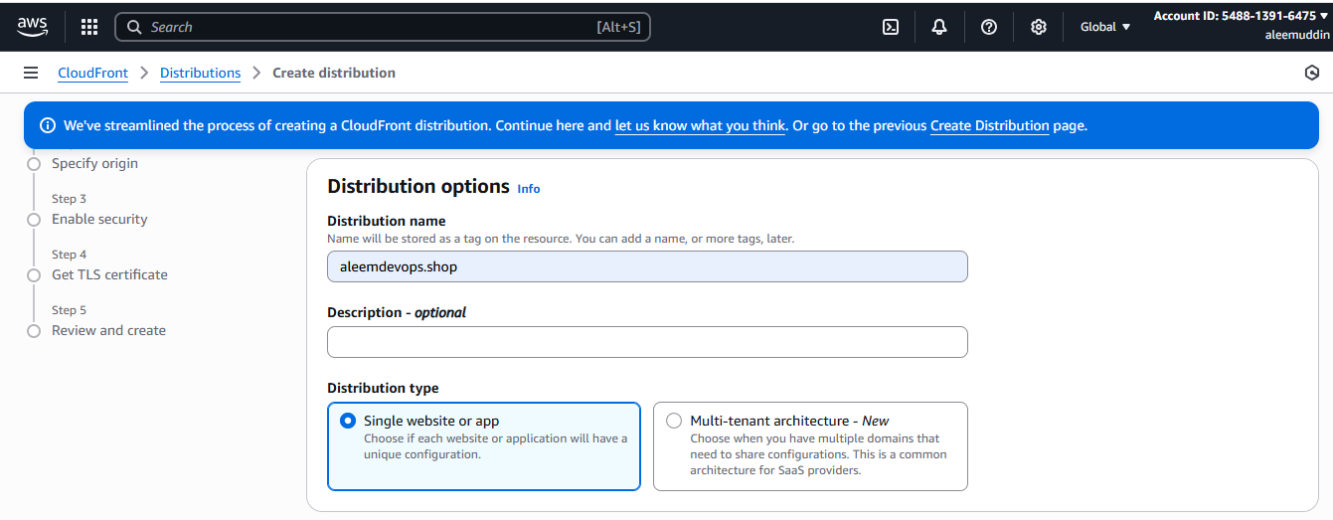

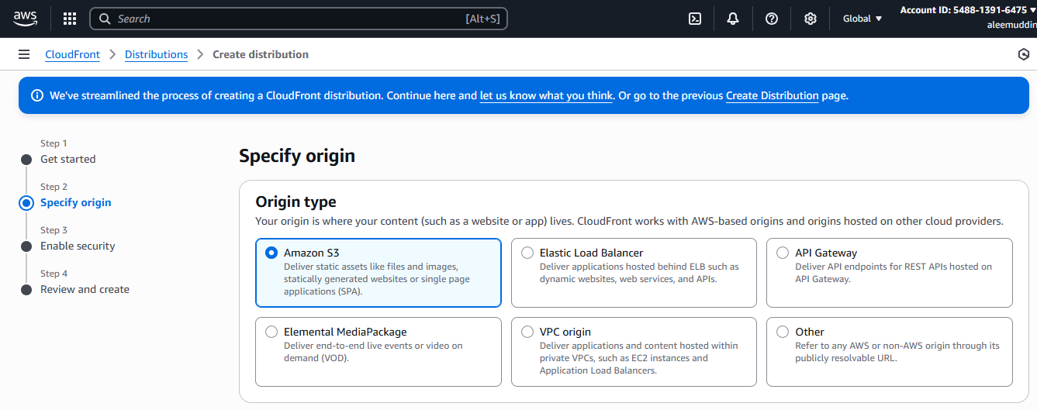

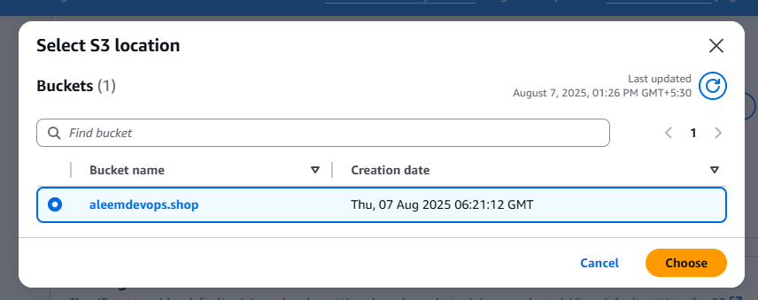

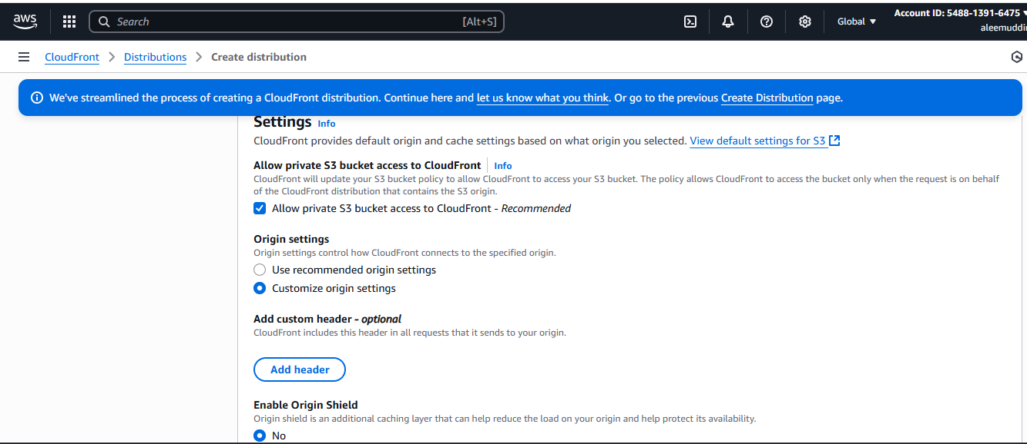

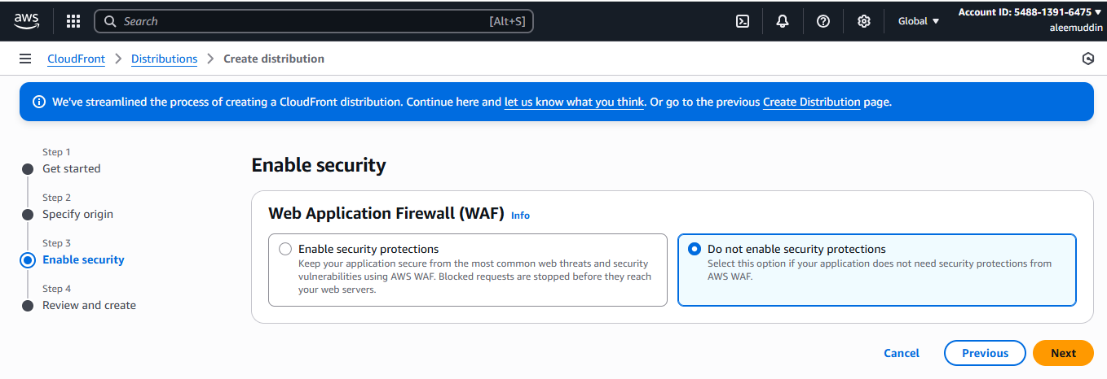

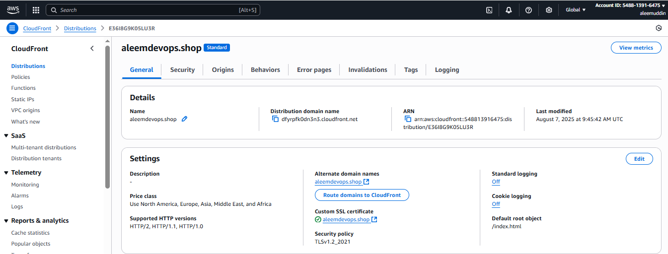

1. **Create Route53 hosted zone and MAP the domain with CDN.**

**Step-1: Create Hosted zone & Add domain.**

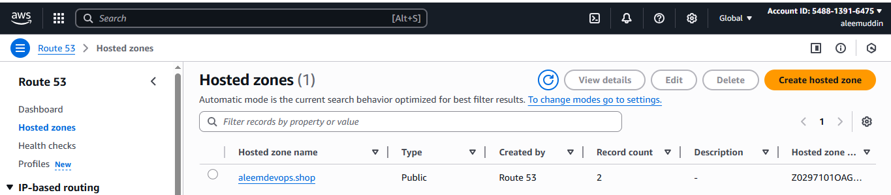

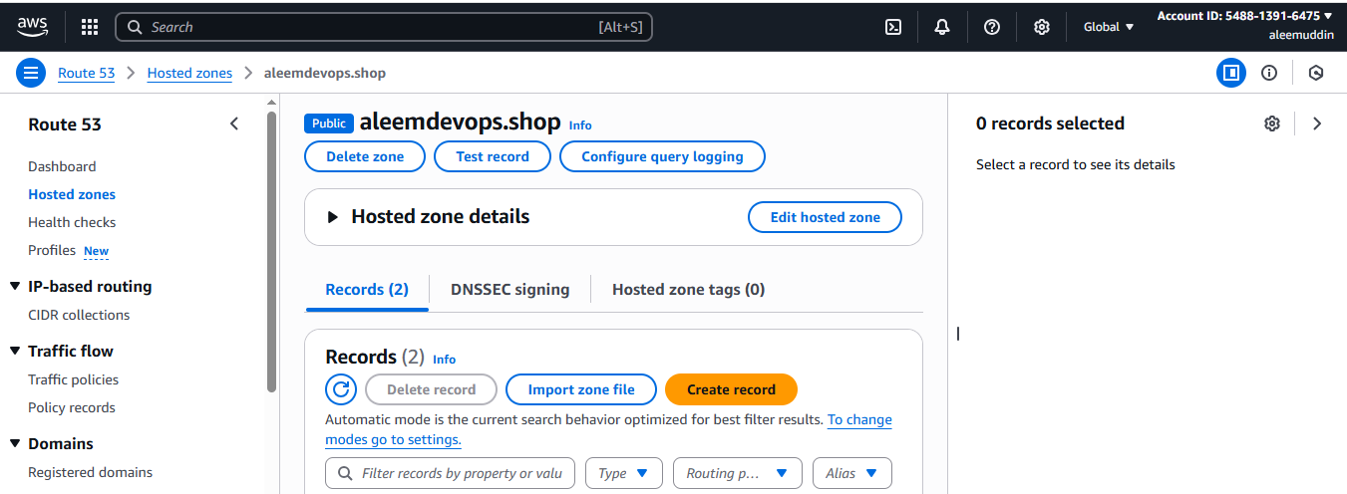

**Step-2: Click on Create record to map cdn.**

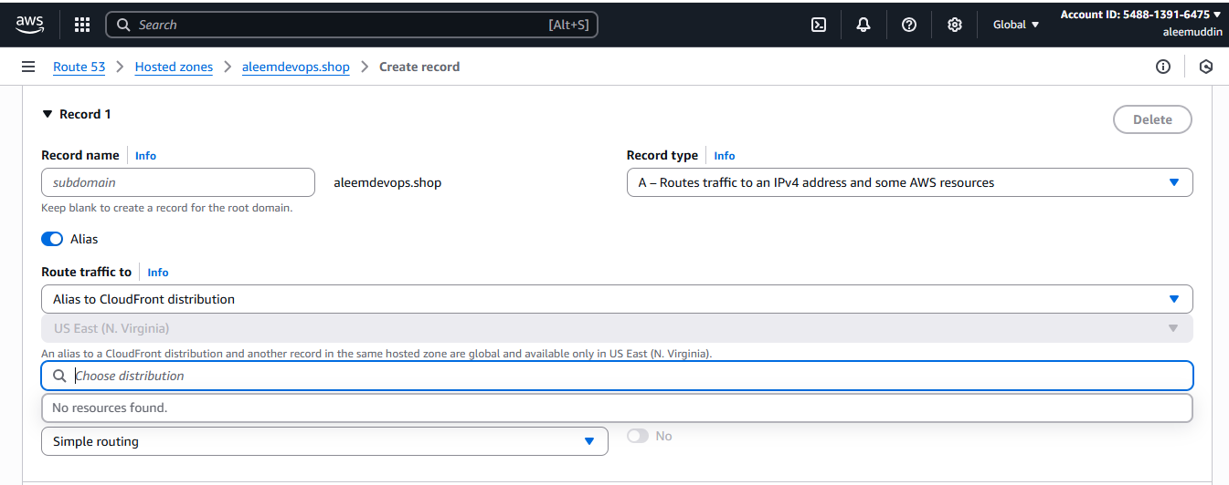

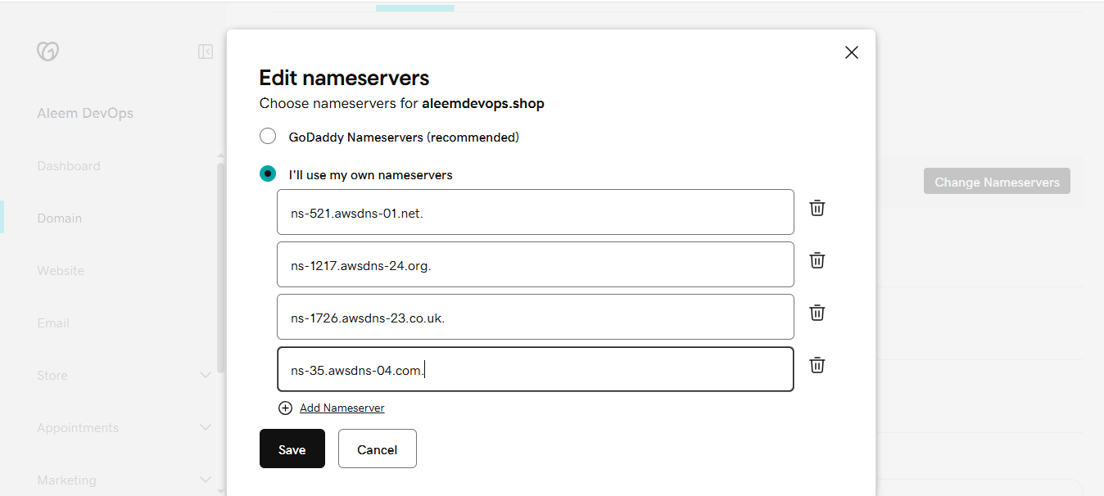

**Now we can see CNAME in the list**

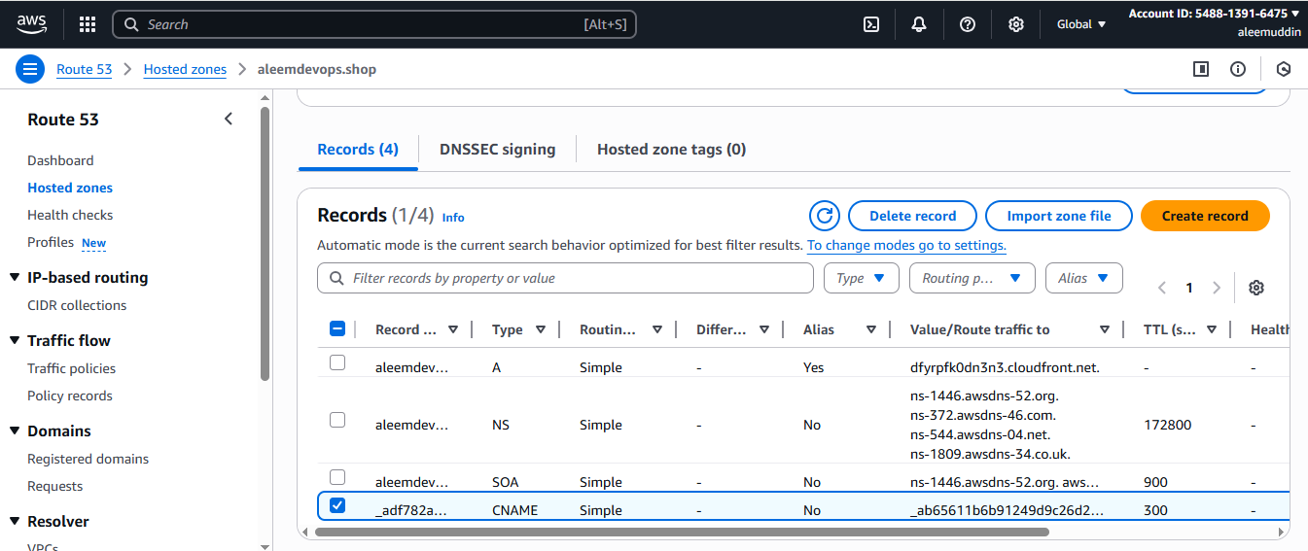

1. **Update the index.html in s3 bucket and the updated file should be accessible by using domain**

**name.**

**http://aleemdevops.shop.s3-website.ap-south-1.amazonaws.com/**

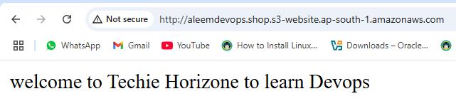

1. **Share the Domain name in slack to test the connectivity.**

**https://aleemdevops.shop/**

